The idea of this task is very simple, we’re using two joysticks to complete the task, the user needs to hold both joysticks and tries to navigate both of them in a specific direction that we provide for him. After he manages to do the task correctly, a password will be displayed on the LCD. By writing that password on the application the task will be completed and he will process to the next task or he will be finished with all of them.

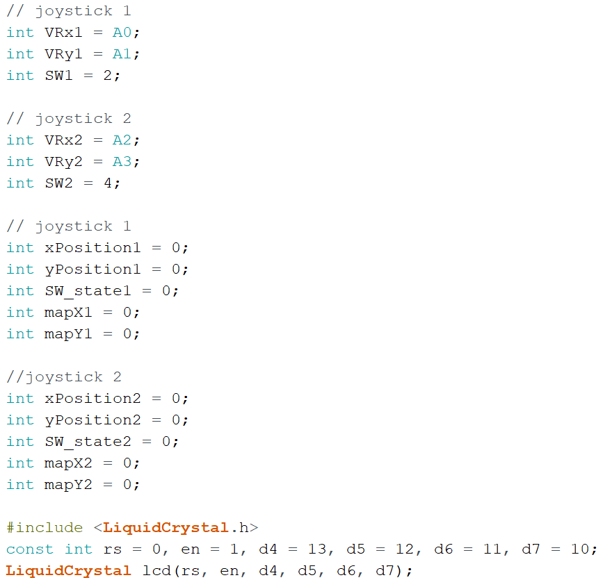

* Variables declaration for both joysticks X’s and Y’s positions. And adding the library.

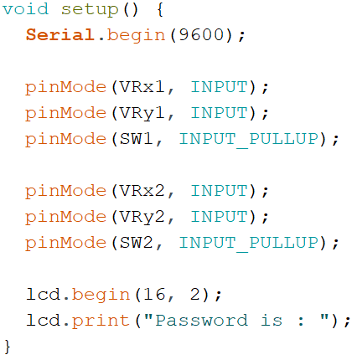

* In the setup(), we’re assigning both joysticks pins as inputs, and getting the LCD ready to run.

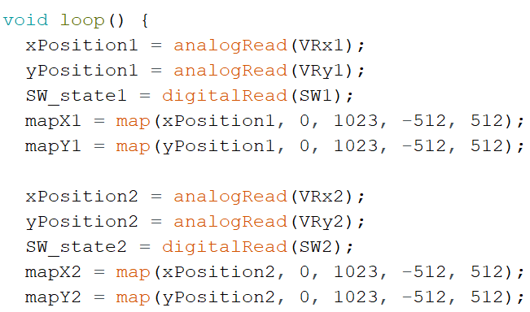

* Here in the loop we are reading the positions of both X’s and Y’s of the joysticks when the user start navigating them, \*\* means its directed upwards, \*\* down, \*\* left, and \*\* right. The mapping is used to prevent errors from happening, for example, when the user is holding both joysticks and pointing them upwards but there’s a slightly unnoticeable difference, and both joysticks are not matching, this mapping will make it as if they are both matching and pointing at the same exact direction.

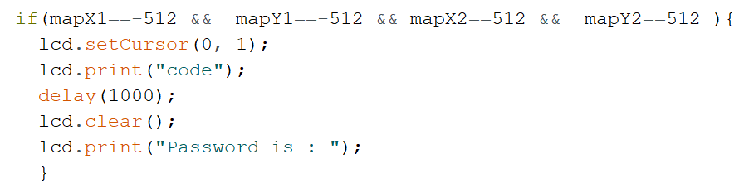

* This if condition here finds out if the user is pointing both joysticks at the same direction. And then printing the password on the LCD.